**Project Workplan**

A project workplan is a list of tasks in the form of a schedule with built-in dependencies and milestones. The project work plan can be used as the "road map" for a project. This plan would be the product of your team’s brainstorming about tasks, their expected durations, dependencies, and milestones. Making a diagram using Post‑its and markers on a whiteboard will be a very useful starting point:



Such a diagram will then be used by the project manager to create a Gantt or bar-chart. The output can be shared with the team for the purpose of activity monitoring to track progress.

If you have a preference toward tables as compared to diagrams, you may choose a format similar this example:

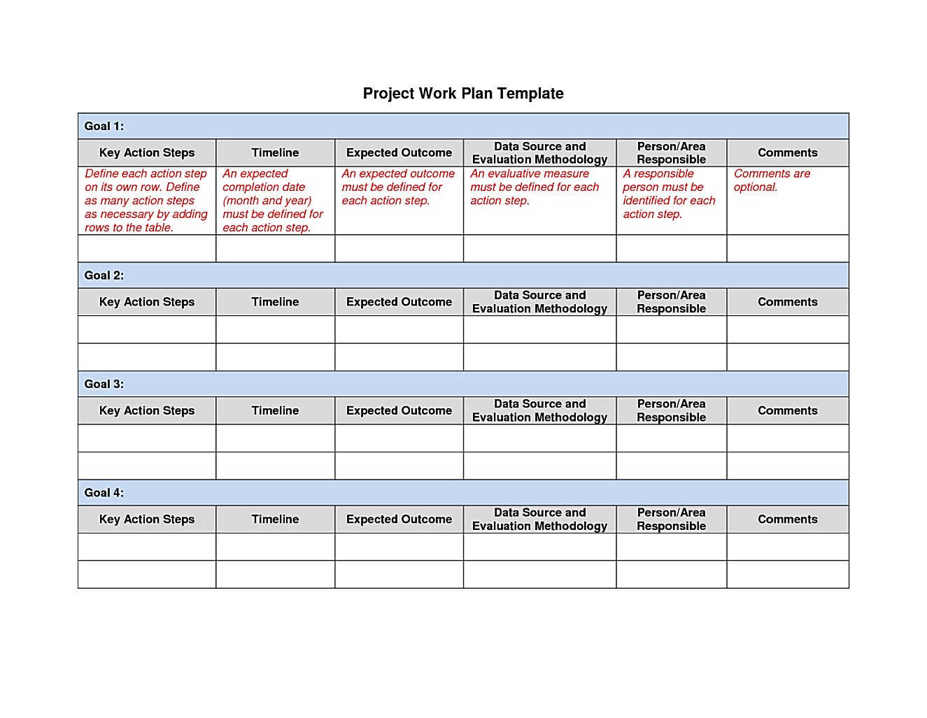000